Sri Lanka Institute of Information Technology



IT1040 - Fundamentals of Computing

Year 1, Semester 1- 2024

**Green House Automation System**

Progress Report

Group P4-9

|  |  |
| --- | --- |
| **IT Number** | **Name** |
| IT24103399 | Jayasooriya J.M.N.R |
| IT24101780 | Wanigasekara Y.A. |
| IT24102291 | Premaratne B.B. |
| IT24102732 | Maduranga H.M.M.P. |
| IT24102617 | Imesha I.G.S. |
| IT24103337 | Safak Ahamed M.I |

# Introduction

The Greenhouse Automation System is designed to modernize and enhance traditional greenhouse operations by integrating advanced technologies for seamless management of plant growth and environmental factors. By automating essential tasks like climate control, irrigation, and lighting, the system reduces the need for manual labor while maximizing resource efficiency. Our solution tackles issues such as water wastage, inconsistent monitoring, and security vulnerabilities, providing a reliable, data-driven approach to greenhouse management. This report outlines the progress made in developing and testing these features, emphasizing how automation and AI-driven insights contribute to a more sustainable, secure, and efficient greenhouse management system. With future upgrades, the system aims to incorporate predictive analytics, advanced sensors, and broader wireless capabilities, moving toward full AI integration for smarter, self-optimizing greenhouse operations.

# System Architecture

The Greenhouse Automation System is built on a modular architecture that integrates hardware, software, and AI to provide an efficient, automated management solution for greenhouses. The system consists of three main components:

1. Environment Peripheral Nervous System  
   This part includes all the sensors and control units set up in the greenhouse. These devices keep track of things like water levels, light, temperature, and humidity to make sure plants grow well.  
   1. Neural Sensor Nodes  
      Each plant will be monitored by a dedicated small circuit featuring an ATMega168 micro-controller. This low-cost and easy-to-maintain circuit will read sensor values and send them to the Central Neural Hub. It will also perform actions affecting a single plant or a group of plants based on commands from the Central Neural Hub.
   2. Sensor Hub  
      This ensures the connection between Neural Sensor Nodes and the Central Nervous System. It also provides security for each greenhouse and monitors environmental variables that affect the entire greenhouse (such as temperature and humidity). Additionally, it performs actions that impact the whole greenhouse based on environmental conditions, schedules, or user overrides.
2. Central Nervous System  
   This part includes the mobile app and cloud services that manage and store data. It allows us to check and control the greenhouse from anywhere. The app, developed using Flutter, provides a pixel-perfect, user-friendly interface for monitoring and controlling the greenhouse system. This part of the system also securely stores all sensor data, user information, and event logs. Additionally, cloud functions run to perform actions based on data and make decisions based on current information.
3. Cognitive Nexus  
   This part is where the AI comes in, a surprising feature that many of you might not expect from us. It uses advanced algorithms to analyze data and make decisions to improve greenhouse management. Currently, we are using a custom AI model based on Google’s Gemma-2-27b, trained on the latest research in this field. It is also trained to interact with people in a more friendly manner, rather than as an official bot.

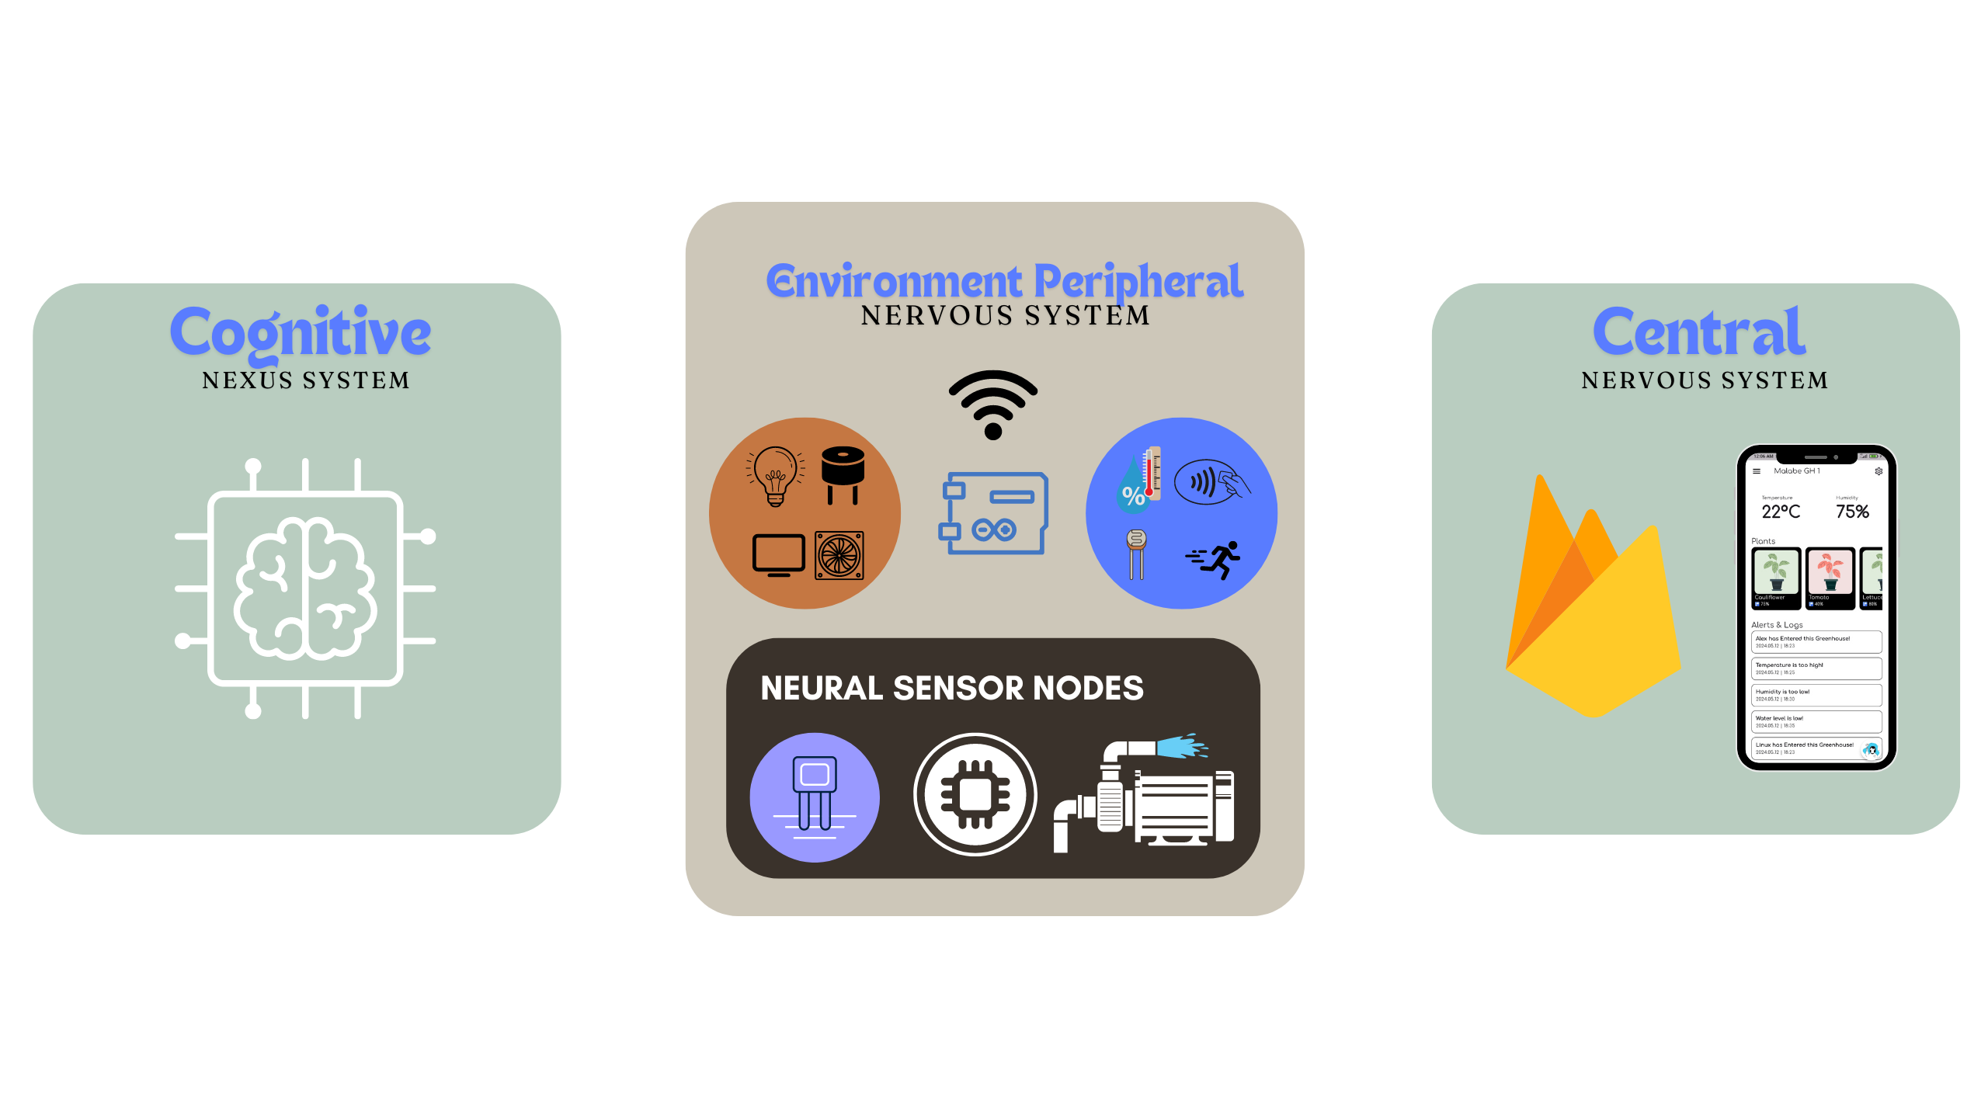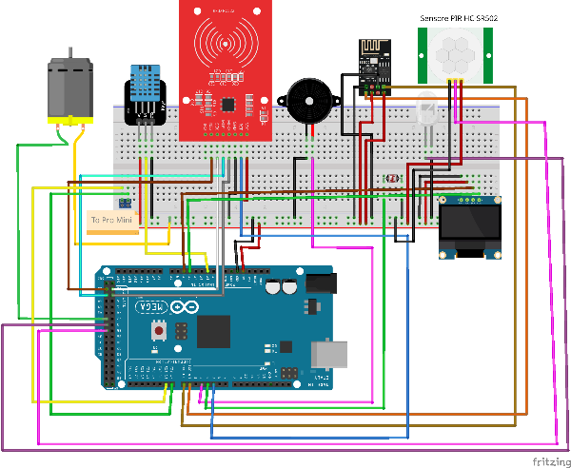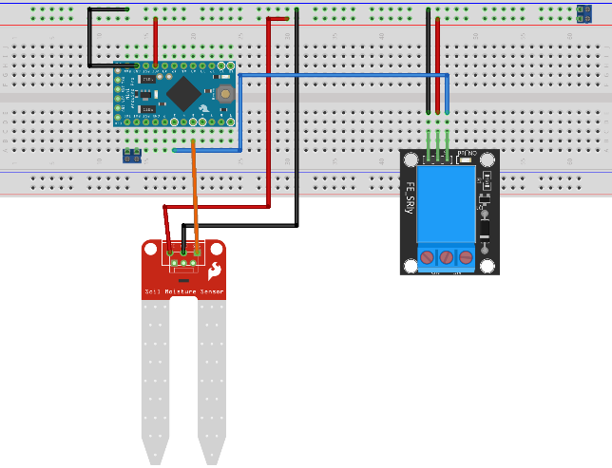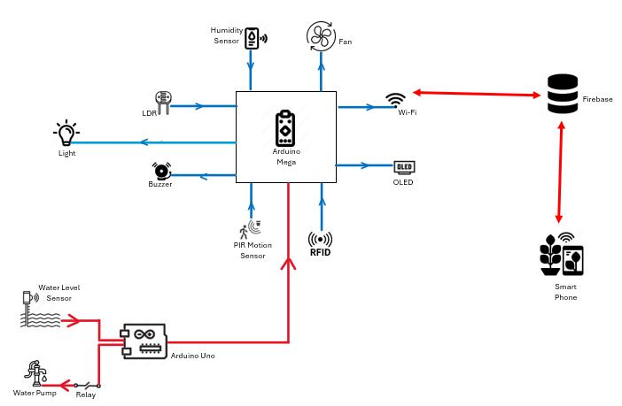

# Work Breakdown Structure

# Proof of Work

